Linux Questions

- What is Umask? How it works.
Ans. umask (short for user file creation mask) is a default permission setting that determines the permissions that are removed when a new file or directory is created.
- Default permissions (before umask is applied):
  - File: 666 → rw-rw-rw- (read/write for user, group, others)
  - Directory: 777 → rwxrwxrwx (read/write/execute for all)
- umask value is subtracted (bitwise) from these defaults to give the final permissions.
Example:
umask
# Output: 022
- 022 means:
  - Owner: 0 → no permissions removed
  - Group: 2 → write permission removed
  - Others: 2 → write permission removed

2. How would you diagnose and resolve performance degradation on a Linux Server?
Ans. Here’s how to diagnose and fix it step by step:

Step 1: See who/what is eating resources
- Run: top Command
- Look for: CPU hogs means processes using too much CPU
Memory hogs means processes using too much Ram

Step 2: Check disk space
- Run: df -h Command
- Make sure you’re not out of space. Full disks can make things slow.
- Action: Delete or archive old files if disk is almost full.

Step 3: Check disk I/O (read/write speed)
- Run: iostat -x 1 5
- If %iowait is high, your disk is busy.
- Action: Move logs, add faster storage, or check which process is hammering the disk.

Step 4: Check memory usage
- Run: free -h
- Look at used vs available RAM.
- If RAM is low and swap is being used a lot, server slows down.
- Action: Kill memory-heavy processes or add more RAM.

Step 5: Check running services
- Sometimes a service is stuck or looping.
- Run: systemctl status <service_name>
- Action: Restart the service if needed.

Step 6: Check network usage
- Run: netstat -plant or iftop
- See if any process is flooding the network.
- Action: Investigate heavy network processes or firewall issues.
3. What is a symbolic link?
Ans. A symbolic link (or symlink) in Linux is a type of file that serves as a pointer to another file or directory. Unlike a hard link, which directly references the data on disk, a symbolic link contains a path to the target file or directory. This allows for greater flexibility, such as linking to files on different filesystems or even to directories.
Creating a Symbolic Link: You can create a symbolic link using the ln command with the -s option. The syntax is:
ln -s target_file link_name

4. How do you shut down or reboot the system?
Ans. To shut down or reboot a Linux system, you can use several commands, each serving a specific purpose. The commands require root privileges, so you may need to prefix them with sudo if you’re not logged in as root.
Shutting Down the System: To shut down the system immediately, you can use:
shutdown now
This command will gracefully terminate all processes and power off the machine.
Scheduled Shutdown: You can also schedule a shutdown by specifying a time:
shutdown +5
This command will shut down the system in 5 minutes. You can also specify a specific time:
shutdown 23:00

5. What is the difference between wget and curl?
Ans. wget and curl are both command-line tools for transferring data over various network protocols, but they have different features and use cases.
- wget:
  - Primarily designed for downloading files from the web using HTTP, HTTPS, and FTP protocols.
  - Can download files recursively, which is useful for mirroring websites or downloading multiple files in a directory.
  - Supports resuming downloads if interrupted using the -c option.
  - Operates mainly in a non-interactive manner, making it suitable for scripts and background processes.

- curl:
  - A versatile tool that supports a wider range of protocols, including HTTP, HTTPS, FTP, FTPS, SCP, SFTP, and more.
  - It is commonly used for sending and receiving data through various means, such as APIs.
  - Offers extensive options for configuring requests, including headers, cookies, and data formats (e.g., -d for POST requests).
  - Curl is often used in scripts to interact with APIs or perform complex requests.
6. How do you change the priority of a running process?
Ans. In Linux, the priority of a running process can be changed using the renice command. This command adjusts the "niceness" value of a process, which influences its scheduling priority.
- Understanding Niceness: The niceness value ranges from -20 (highest priority) to 19 (lowest priority). By default, processes start with a niceness of 0.
Changing Priority with renice: To change the priority of a running process, you need its Process ID (PID). The syntax is:
renice [niceness] -p [PID]
For example, to lower the priority (increase niceness) of a process with PID 1234:
renice 10 -p 1234
Adjusting Priority: To raise the priority (decrease niceness) of a process:
renice -5] -p 1234
- Root Privileges: Only the root user can increase the priority (decrease niceness) of a process.

7. How can you find processes consuming the most memory?
Ans. To find processes consuming the most memory in Linux, you can use several commands, with ps, top, and htop being among the most effective.
Using ps: The ps command displays information about running processes. To find processes sorted by memory usage:
ps aux –sort=-%mem | head
This command shows all processes (aux) sorted by memory usage in descending order, displaying the top results with head.
- Using top: The top command provides a dynamic, real-time view of system processes. To sort by memory usage while in top, press M. This will rearrange the displayed processes, showing those using the most memory at the top.

- Using htop: htop is an enhanced version of top, offering a more user-friendly interface. Install it if it's not already available:
sudo apt install htop
- Run htop in the terminal. You can sort processes by memory usage by clicking on the column header or using function keys.

8. What is a Linux kernel module?
Ans. A Linux kernel module is a piece of code that can be loaded into the Linux kernel at runtime to extend its functionality without requiring a complete reboot. Kernel modules are used to add support for new hardware, filesystems, or system calls, and they can be dynamically loaded and unloaded as needed.
- Types of Modules:
  - Device Drivers: These modules provide interfaces for hardware devices, enabling communication between the hardware and the kernel.
  - Filesystems: Modules that allow the kernel to read and write data to different types of filesystems.
  - Networking: Modules that add support for various networking protocols and features.
- Loading and Unloading Modules:
To load a module, use the insmod command:
sudo ismod module_name.ko
To unload a module, use the rmmod command:
sudo rmmod modeule_name
Checking Module Information: The modinfo command provides detailed information about a specific module:
modinfo module_name
9. How do you understand about the standard streams?
Ans. Output and Input in Linux OS are divided into three standard streams:
- Stdin (standard input)
- stdout(standard output)
- stderr (standard error)
10. How do you mount and unmount filesystems in Linux?
Ans. For mounting:
- First, identify the partition through the fdisk -l command. You can also use the lsblk command for it.
- After identifying the partition, create the directory which will work as the mount point. For example, running the mkdir /mnt/mountpnt will create the mountpnt directory as the mount point.
- Finally, you can run sudo mount <partition> <mount_point_directory> to complete the mounting.
For Unmounting:
Once you check if the specific filesystem is in use, you can run the `sudo umount <mount_point_directory>` for unmounting.

11. How do you troubleshoot network connectivity issues in Linux?
Ans. Check the Internet Connectivity:
First of all, please check if the internet connection option is on and also check the cables to find if there is any issue with it.
Verify the Network Configuration:
- Please check that your network is configured correctly and the network interface has your IP address. You can check it by running the ip addr or ifconfig commands.
- You can also run the ip route command to check if the default gateway is set properly.
- Finally, verify the DNS server configuration in the /etc/resolv.conf file.
Check the Firewall:
Sometimes, firewall rules block the internet connection for the system's security. Hence, you can run the ufw or iptables command to modify the firewall rules.
Network Interface:
You can restart your network interface through the ifup and ifdown commands. Once you restart the network interface, please reboot the system to make changes successful.

12. What is the /proc file system?
Ans. proc (Proc File System) is the virtual file system that shows information about the system and the Kernel data structures. It is the essential interface to access the system, perform debugging tasks, check the Kernel functioning, find process-related information, and many more.

13. What is strace command?
Ans. The strace command is the diagnostic utility by which you can trace and monitor the system calls generated by the process. It allows you to find how programs interact with Kernel and can be used for debugging and troubleshooting. For example, let's find the system calls generated by the ls command:
strace ls
Once you run the above command, the system will start tracing the list command and show the system calls generated by it. Output from the above command includes information like call name, argument, and return values.

14. How do you optimize Linux system performance?
Ans. You can optimize the Linux performance through various strategies to improve resource usage and efficiency. So some of the strategies are:
- Updates the system as per the latest one available.
- Optimize the disk, enable the caching, and optimize the access pattern.
- Manage memory and CPU usage.
- Disable the necessary services and use lightweight alternatives of the tools.
- Monitor the system resources regularly.
- Perform the Kernel parameter tune-up.
- Use tools like Performance Co-Pilot (PCP) to monitor system-level performance.
15. How do you troubleshoot a Linux OS that fails to boot?
Ans. In case of the system boot failure, you can follow various approaches such as:
- Check the warning and error messages you get during the boot process because it can help you diagnose the issues.
- Check the boot logs to find the exact reason behind the boot error.
- Open the GRUB bootloader and check the boot options to solve the booting problems.
- Check the hardware connections like cables, RAM, cooling fan, etc.
- If the system shows an error message related to the Kernel, try to boot it with the older Kernel version from GRUB.
- Identify the last changes you made in the system before the boot.

16. What are runlevels in Linux?
Ans. Runlevels in Linux define different system states, such as single-user mode or multi-user mode with or without a GUI. They determine which services start or stop during system startup and shutdown. The default runlevel is often set to a multi-user mode with a GUI (runlevel 5). Runlevel 3 is commonly used for a multi-user mode without a GUI.
17. How do you recursively copy files and directories in Linux using the cp command?
Ans. In linxux we can simply use `-R` option with the `cp` command to recursively copy the file and directories.

For example:
cp -R sourece_durectory destination_directory

18. How are files organized in Linux?
Ans. Linux follows a hierarchical file system structure. The root directory is denoted by "/", and files are organized in directories or folders within the root directory.

19. How can you find the IP address of a Linux system?
Ans. The 'ifconfig' or 'ip addr show' command can be used to display the IP address of a Linux system.

20. How do you start and stop a service in Linux?
Ans. The 'systemctl start <service>' command is used to start a service, and 'systemctl stop <service>' is used to stop a service in Linux.

21. How do you troubleshoot a Linux system that cannot connect to a remote server?
Ans. Possible troubleshooting steps include checking network connectivity using tools like 'ping', verifying firewall rules, checking DNS settings, and examining relevant log files for error messages.

22. What steps would you take to fix a network connectivity issue in Linux?
Ans. Steps would include checking physical connections, verifying IP configuration, checking firewall settings, ensuring DNS resolution is working, and using network troubleshooting tools like 'ping', 'traceroute', or 'tcpdump'.

23. How do you check the system logs in Linux?
Ans. System logs can be checked using the 'tail' or 'less' command to view the contents of log files located in the '/var/log' directory, such as 'syslog', 'messages', or 'auth.log'.

24. What are the possible reasons for a Linux system running out of memory?
Ans. Possible reasons include memory leaks in applications, excessive memory usage by running processes, inadequate memory allocation, or high memory demands from large datasets.
25. How would you troubleshoot a slow-performing Linux server?
Ans. Troubleshooting steps might involve checking system resource usage with tools like 'top' or 'htop', monitoring disk I/O, analyzing network traffic, identifying memory or CPU bottlenecks, and reviewing application logs.
26. How do you set up a fixed IP address in Linux?
Ans. A fixed IP address can be set up in Linux by editing the network configuration file (e.g., '/etc/network/interfaces' or '/etc/sysconfig/network-scripts/ifcfg-<interface>') and assigning the desired IP address to the interface.
27. What are the differences between Cron and Anacron?
Ans. Cron is a job scheduled to be executed at a later time in a Linux server. One example could be scheduled backups of log files or databases. Anacron is Cron, which is used on a workstation or client that is not expected to be always on or connected to a network. While Cron can be set on a minute basis, Anacron can be set on a day basis at the minimum level. Any user can set the Cron, but Anacron can be set only by a superuser. Since Cron is set on servers that are up all the time, it will be executed at the time scheduled. Anacron does not expect the machine to be set up all the time and hence is executed whenever the system is up and available.
28. What is the role of the init or systemd process in Linux?
Ans. init or systemd is the first process started by the Linux kernel during boot. It initializes the system, starts essential services, and manages system states. systemd is now the default in many distributions, offering faster boot times and better service management through units and targets.

29. Explain the Zombie process.
Ans. The Zombie process, also called a defunct process, is one that is already executed and still waiting in the process table. These are the child processes that are waiting for the parent to execute the system wait call. Remember that the zombie processes will not be killed by the kill call. It remains in the process table till the parent explicitly executes that system wait call.

30. What is the difference between hard and symbolic links in Linux?
Ans. Hard links point directly to the inode of a file, making them indistinguishable from the original. Symbolic (soft) links are shortcuts that reference the file path. Hard links can't span file systems or link directories, while symbolic links can. Use ln for hard links and ln -s for symbolic links.

31. What is the role of systemctl in managing services?
Ans. systemctl is a command-line tool used to manage services in systems running systemd. It allows starting, stopping, enabling, disabling, and checking the status of services. For example, systemctl status nginx shows the current state of the Nginx service. It's essential for service control and troubleshooting.

32. Describe how the `kill` and `killall` commands work.
Ans. The `kill` command terminates a process by sending it a signal, typically `SIGTERM` (signal 15) or `SIGKILL` (signal 9). To terminate a process, use `kill -9 PID` where `PID` is the process ID. The `killall` command, however, terminates all processes with a specified name, e.g., `killall firefox` closes all instances of Firefox. While `kill` is useful for handling individual processes, `killall` is efficient for managing multiple processes of the same application or service.

33. Explain Daemon.
Ans. Daemons offer special functionalities that are not available in the operating system by default. It stays active and listens to every service request and activates the required services that are not offered by the operating system. Once the said service gets done, it remains dormant and waits for the next service.

34. What is the significance of /etc/fstab in Linux?
Ans. /etc/fstab is a configuration file that defines how disk partitions, network shares, and other file systems are mounted at boot. Each line specifies a device, mount point, file system type, and options. Proper configuration ensures reliable and automated mounting of storage resources.

35. Explain the following:
a) awk
b) sed
c) rsync

Ans. Awk is a scripting language used to create small programs for data searching and manipulation. It does not require compiling and offers extensive string, numeric, and logical manipulations and functions. It is best used for pattern-scanning.
The sed command is used for string manipulation in Linux. It is used for text stream manipulation and is extensively used for find & replace of text and complex pattern-matching.
The rsync command is used for remote syncing of files. You can use this to copy files faster locally and remotely. It does not support copying files between two remote hosts, though.

36. Explain the Kernel and what it can provide.
Ans. Kernel refers to a modular operating system. The kernel has modules that could be loaded dynamically during runtime, and it could extend its capabilities. A Kernel module could provide the following:
a) A Device Driver: This adds Support for New Hardware
b) File System Support: NFS (Network File System) or BTRFS (Modern Copy On Write File System)
Kernel modules have parameters through which we can customize the behavior of the system. The Kernel modules could be loaded or unloaded as and when required.

37. How would you troubleshoot and resolve a “Too many open files” error in Linux?
Ans. The "Too many open files" error typically occurs when a process exceeds the file descriptor limit set by the system. To diagnose, you can use `ulimit -n` to view the current limit and `lsof | wc -l` to see the number of open files. To temporarily increase the limit, use `ulimit -n 4096`. For a permanent change, edit `/etc/security/limits.conf` and add lines like `username soft nofile 4096` and `username hard nofile 8192`. This error often requires adjusting system limits or optimizing applications to handle file descriptors better.

38. What is the difference between fork() and exec() in Linux programming?
Ans. fork() creates a new process by duplicating the calling process, while exec() replaces the current process image with a new one. Typically, fork() is used to create a child process, and exec() is used within that child to run a different program. Together, they enable process creation and execution in Unix-like systems.

39. What is the purpose of `systemd`, and how does it manage services in Linux?
Ans. `systemd` is an init system and service manager for modern Linux distributions, responsible for booting and managing services, logging, and handling dependencies. It replaces older init systems like `SysVinit` and allows for parallel service startup, reducing boot time. To manage services, commands include `systemctl start servicename`, `systemctl stop servicename`, and `systemctl status servicename`. `systemd` also supports unit files that define services, targets, and sockets, making it an advanced and flexible system for process and service management.

40. What is the difference between nice, renice, and ionice in Linux?
Ans. nice sets the priority of a process at launch, affecting CPU scheduling. renice changes the priority of an already running process. ionice controls I/O scheduling priority, useful for disk-intensive tasks. These tools help manage system performance by adjusting how resources are allocated to processes.

41. How do you find out which user is currently logged in?
Ans. The method for determining the currently logged-in user depends heavily on the specific operating system, programming language, and framework in use. However, here are some general approaches:
- Operating System Level: Most operating systems store the currently logged-in user's information in environment variables or system calls. For example, in Linux/macOS, you might use the whoami command in the terminal, or access the $USER environment variable. Windows has similar environment variables and API calls for user identification. For example, a user might use GetUserName() in Windows API to get the logged in user.
- Application Level: Web applications often use session management to track logged-in users. The server stores a session ID (often in a cookie), which is associated with a specific user's data. So you can check that session to find the user details. Similarly desktop applications could use a class that saves the user once logged in and other parts of the application can access that class to identify the user.

42. Explain what the command 'chmod' is used for. A brief explanation is fine.
Ans. The chmod command in Unix-like operating systems (Linux, macOS, etc.) is used to change the access permissions of files and directories. It allows you to control who can read, write, and execute a file.
For example, chmod 755 my_script.sh makes the script executable by its owner and readable and executable by others.
43. What are the types of hardware typically found in server systems and how are they configured in Linux?
Ans. Server systems typically include components like CPUs, RAM, storage drives (HDDs/SSDs), network interface cards (NICs), and sometimes specialized hardware like RAID controllers. In Linux, hardware configuration can be done through various commands like lspci to list PCI devices, lsblk to view block devices, and configuring storage through tools like fdisk or parted. Additionally, server settings can be managed through configuration files and system utilities.
44. Explain how to interact with a Linux system using a terminal and basic shell commands.
Ans. Interacting with Linux through the terminal is a powerful way to perform tasks. Basic shell commands include ls to list files, cd to change directories, cp to copy files, and rm to remove files. Using the man command (e.g., man ls) can provide detailed information about any command, which is incredibly helpful for learning.

45. What are the advantages and disadvantages of open source?
Ans. Open source is free and available to the public, so users can download the file and change the code as desired. As long as they use the same licence, they can even sell copies of the modified code. The disadvantages of open source include the possibility that it can make the software less compatible with other hardware and systems and more challenging to use. Open source also lacks user support because potentially thousands of contributors created it, which belongs to the public.

46. Can you describe a time you fixed an especially difficult bug? How did you resolve it?
Ans. VI stands for Visual Editor. It is a default text editor. There are three types of modes in the VI editor.
- Regular mode/Command mode.
- Insertion mode/Edit mode.
47. Write the various process states in Linux.
Ans. he process states in Linux can be in many different states. Different process states are as follows:
- New/Ready: This is a state where a new process is created and also ready for the run.
- Running: This is a state where execution takes place.
- Blocked/wait: This is a state where the process waits for the user to provide input.
- Terminated/completed: This is a state where the process completes with the execution part.
- Zombie: This is a state where the process is terminated. The process consists of information after the termination as well.

48. What is an inode in Linux?
Ans. An inode is a data structure that stores information about a file, such as file size, ownership, permissions, and data block pointers. It does not store the file name, which is managed separately in the directory structure.
49. What are kernel, bootloader and shell?
Ans. The kernel is the heart of the operating system. It’s the bridge between hardware and software — it manages everything your computer does.
The bootloader is the first program that runs when you turn on your computer. It’s responsible for loading the operating system (kernel) into memory.
The shell is the interface between the user and the kernel. It takes the commands you type and asks the kernel to execute them.

50. How do you check system resource usage ?
Ans. Linux provides multiple tools to monitor system performance:
- top or htop shows real-time CPU, memory, and process usage.
- df -h displays disk space usage
- free -m reports memory usage
- iostat or vmstat can be used to monitor I/O performance and system statistics.

AWS Questions

- What are different types of cloud services?
Ans . Software as a Service (SaaS), Data as a Service (DaaS), Platform as a Service (PaaS), and Infrastructure as a Service (IaaS).
- What is the type of architecture, where half of the workload is on the public load while at the same time half of it is on the local storage?

Ans. Hybrid Cloud Architecture

- What is the way to secure data for carrying in the cloud?
Ans. One thing must be ensured that no one should seize the information in the cloud while data is moving from point one to another and also there should not be any leakage with the security key from several storerooms in the cloud. Segregation of information from additional companies’ information and then encrypting it by means of approved methods is one of the options. Amazon Web Services offers you a secure way of carrying data in the cloud.

- Is it possible to change the private IP addresses of an EC2 while it is running/stopped in a VPC?
Ans. The primary private IP address cannot be changed. Secondary private addresses can be unassigned, assigned or moved between interfaces or instances at any point.

- Is it possible to scale an Amazon instance vertically? How?
Ans. Yes. This is an incredible characteristic of cloud virtualization and AWS. Spinup is a huge case when compared to the one which you are running with. Let up the instance and separate the root EBS volume from this server and remove. Next, stop your live instance, remove its root volume. Note down the distinctive device ID and attach root volume to your new server and start it again. This is the way to scaling vertically in place.
- Is it possible for an EC2 classic instance to become a member of a virtual private cloud?
Ans. No, it is not possible for an EC2 classic instance to be a member of a VPC though it can become a member of the security group of virtual private cloud. The security group should be associated with the EC2 classic instance.

- What AWS services have you used in production?
Ans. EC2 for compute resources
S3 for storage and backups
RDS (MySQL) for managed databases
EKS (Elastic Kubernetes Service) for container orchestration
IAM for access control
VPC, Subnets, NAT Gateway for networking
CloudWatch for monitoring and alerts
CloudFormation/Terraform for provisioning• Load Balancers (ALB/NLB) for traffic routing

- Your EC2 instance in a private subnet needs to download packages without a NAT Gateway. What alternatives exist?
Ans. S3 Gateway Endpoint — best for yum/apt repos if packages mirrored to S3.
VPC Interface Endpoint (AWS PrivateLink) — e.g., for ECR, SSM, SNS, etc.
NAT instance — cheaper but less managed than NAT Gateway.
Proxy in public subnet — squid proxy + security groups.
SSM Agent with IAM role — use SSM to execute package install without outbound internet.
- How would you allow private subnets to access the internet without exposing them directly?
Ans. To allow private subnets to access the internet without exposing them directly, I would use a NAT Gateway (or a NAT Instance) in a public subnet. The NAT Gateway acts as an intermediary — it allows instances in the private subnet to initiate outbound traffic to the internet (for software updates or external APIs), but it blocks all inbound connections from the internet.
Here’s how it works:
- The private subnet’s route table has a default route (0.0.0.0/0) pointing to the NAT Gateway.
- The NAT Gateway itself uses the Internet Gateway attached to the VPC to access the internet.
- This setup ensures that private instances can reach the internet securely, while remaining inaccessible from the outside world.

- Your application requires low latency and high throughput between two VPCs across different AWS accounts. What’s the best solution?
Ans. The best solution is to use VPC Peering between the two VPCs.
VPC Peering provides a direct network connection between two VPCs — even if they’re in different AWS accounts — using private IPs, without traffic going over the public internet.
It offers low latency and high throughput because traffic stays within the AWS backbone network, ensuring speed and security.
- What is cross-zone load balancing and when should you enable it?
Ans. Each load balancer node only sends traffic to targets in its own Availability Zone. If one AZ has fewer instances, it may become overloaded, while others stay underutilized.
Each load balancer node can send traffic to all targets across all AZs — resulting in:
- Even distribution of traffic
- Better performance and utilization
- Higher availability
- Will I be billed for the IOPS provisioned on a Provisioned IOPS volume when it is disconnected from an instance?
Ans. Yes, you will still be billed for the provisioned IOPS and storage of a Provisioned IOPS (io1 or io2) EBS volume even when it is detached from an instance.
This is because AWS reserves the storage and IOPS capacity specifically for you, regardless of whether the volume is attached or not. The billing continues until you delete the volume.
If you want to avoid charges, you can take a snapshot of the volume for backup and then delete the volume itself.
For example, if you create a 100 GB io1 volume with 3,000 IOPS, you will be charged for both the 100 GB storage and 3,000 provisioned IOPS until the volume is deleted even if it’s not attached to any EC2 instance.

- Can I boot an EC2 instance using a Multi-Attach enabled volume?
Ans. No, you cannot boot an EC2 instance using a Multi-Attach enabled EBS volume. Multi-Attach is supported only for data volumes, not for root (boot) volumes. The root volume of an instance must be attached exclusively to one instance because it contains the operating system files and unique instance configuration data.

- How do I access a file system from an EC2 instance?
Ans. You can access a file system from an EC2 instance by mounting it after establishing the correct network connectivity and permissions. The exact method depends on the type of file system you’re using.

1. Amazon EFS (Elastic File System – for Linux)
- Ensure the EC2 instance and EFS are in the same VPC and security groups allow NFS traffic (port 2049).
- Install the EFS mount helper:
sudo yum install -y amazon-efs-utils
- Mount the EFS file system:
sudo mkdir /mnt/efs
sudo mount -t efs fs-xxxxxxx:/ /mnt/efs

2. Amazon FSx for Windows File Server
- Ensure the EC2 instance has network access to the FSx DNS name.
- From a Windows EC2 instance:
net use Z: \\fs-xxxxxxx.amazonaws.com\share

3. Amazon S3 (Object Storage – not a traditional file system)
- You can access S3 using:
  - AWS CLI: aws s3 cp, aws s3 sync
  - Mount via s3fs-fuse (optional for Linux):
s3fs mybucket /mnt/s3 -o iam_role=auto

- What is an Amazon EFS Access Point?
Ans. An Amazon EFS Access Point is a managed entry point that provides customized access to an EFS file system, defining its own path, user identity, and permissions ideal for securely sharing a single file system across multiple applications.

- How do I transfer data into or out of my Amazon EFS file system?
Ans. First, you “mount” the EFS on a computer, usually an AWS EC2 server. That just means you connect your server to this cloud folder, like plugging in a USB drive.​
- Once connected, you just copy, paste, move, or delete files like you would with any folder on your computer.​
- If you want to move a bunch of files quickly or from outside AWS, you can use special helpers called DataSync or Transfer Family. DataSync is like a super-fast, robot helper for copying lots of files. Transfer Family lets you connect with classic tools like SFTP or FTP.​
- No matter which way you use, it’s all about connecting to EFS and moving files like normal. It just happens in the cloud instead of on your laptop.​

- What is Authentication vs Authorization?
Ans. Authentication
It’s the process of verifying a user’s identity.
Confirms if someone is who they claim to be.
Example: Logging into AWS Console using a username and password or MFA.

Authorization
- It’s the process of determining access rights or permissions.
- Decides what actions or resources a verified user can access.
- Example: After logging in, IAM policies decide whether you can start an EC2 instance or access an S3 bucket.

- Purpose and use of s3?
Ans. Purpose:
- To store and protect data such as files, backups, logs, images, videos, or application data.
- To act as a central storage repository for AWS services and applications.
- To provide high durability (99.999999999%) and availability.
Uses:
- Data Backup and Archiving – Store database or server backups securely.
- Static Website Hosting – Host static web pages (HTML, CSS, JS) directly from S3.
- Data Lake / Big Data Analytics – Store raw or processed data for analytics with services like Athena, Glue, or Redshift.
- Application Storage – Store user uploads, logs, and media files for web and mobile apps.
- Disaster Recovery – Use cross-region replication for backup and data redundancy.
- Software Delivery – Distribute software, updates, or documents to users globally.

17. Should encryption be used for S3?
Ans. Encryption should be considered for sensitive data as S3 is a proprietary technology.

18. How many buckets can be create in AWS by default?
Ans. By default, 100 buckets can be created.

19. How can you send request to Amazon S3?
Ans. You can send request by using the REST API or the AWS SDK wrapper libraries that wrap the underlying Amazon S3 REST API.

20. What Is S3? What Is It Used For? Should Encryption Be Used?
Ans. S3 stands for Simple Storage Service. You can think of it like FTP storage, where you can move files to and from there, but not mount it like a filesystem. AWS automatically puts your snapshots there, as well as AMIs there. Encryption should be considered for sensitive data, as S3 is a proprietary technology developed by Amazon themselves, and as yet unproven vis-a-vis a security standpoint.

21. I created a key in Oregon region to encrypt my data in North Virginia region for security purposes. I added two users to the key and an external AWS account. I wanted to encrypt an object in S3, so when I tried, the key that I just created was not listed. What could be the reason?
Ans. The key created and the data to be encrypted should be in the same region. Hence the approach taken here to secure the data is incorrect. Because AWS KMS keys are region-specific, the key you created in the Oregon (us-west-2) region cannot be used to encrypt data in the North Virginia (us-east-1) region.
Each KMS key exists only within its own region, so it won’t appear or be accessible when you try to use it in a different region’s service — that’s why the key didn’t show up when you attempted to encrypt the S3 object.

22. What is multipart upload, and when would you use it?
Ans. Multipart upload in Amazon S3 is a feature that allows you to upload a single large object as a set of smaller parts. Each part is uploaded independently, and when all parts are uploaded, S3 combines them into a single object. To improve upload performance for large files.
To recover easily from network interruptions — only failed parts need to be re-uploaded.
To upload files in parallel, speeding up the overall upload process.
23. Are delete markers replicated by default in CRR?
Ans. No, delete markers are not replicated by default in Cross-Region Replication (CRR).
When versioning is enabled and you delete an object (without specifying a version ID), Amazon S3 adds a delete marker instead of permanently removing the object. By default, this delete marker is not copied to the destination bucket.

24. What is S3 Server Access Logging, and why is it used?
Ans. Amazon S3 Server Access Logging is a feature that provides detailed records of all requests made to your S3 bucket. These logs include information such as who accessed the bucket, what operations were performed, and when they occurred.

Purpose / Why It’s Used:
- To track access requests for auditing and compliance.
- To monitor usage patterns and identify unauthorized access attempts.
- To analyze traffic for cost optimization and performance tuning.
- Useful for security investigations and troubleshooting issues like unexpected data access.
25. How is data organized in S3?
Ans. Bucket:
  - The top-level container in S3.
  - Every object is stored inside a bucket.
  - Each bucket name must be globally unique across all AWS accounts.
- Object:
  - The actual data stored in S3 (like a file).
  - Each object consists of:
    - Key (object name): The unique identifier within a bucket.
    - Value: The data itself.
    - Metadata: Information about the object (e.g., content type, encryption).
- Prefix (Folder-like structure):
  - S3 uses prefixes in object keys to simulate folders (e.g., images/photo.jpg).
  - It only looks hierarchical in the console, but technically it’s flat.

26. What is CloudWatch Logs Insights? Why is it useful?
Ans. It’s a fully managed interactive log analytics service that allows you to query, analyze, and visualize log data stored in CloudWatch Logs using a custom query language.
It helps you troubleshoot issues faster by filtering and analyzing log data (like errors, latency, or failed requests) directly in the AWS console.

27. How can you publish a custom metric?
Ans. aws cloudwatch put-metric-data --metric-name MemoryUsage --namespace "CustomApp" --value 75

28. What is an SNS Topic in relation to CloudWatch?
Ans. An SNS Topic acts as a communication channel used by CloudWatch Alarms or Events to send notifications (email, SMS, Lambda triggers, etc.) when an event or threshold occurs.

29. You need to monitor the memory utilization of EC2 instances, but it’s not visible in CloudWatch. Why, and how do you fix it?
Ans. By default, EC2 sends CPU metrics but not memory or disk usage. I’d install the CloudWatch Agent to collect and publish custom metrics like memory and disk utilization.

30. Users complain that an application hosted on EC2 is timing out. You have logs in CloudWatch Logs. How do you troubleshoot this?
Ans. I’d use CloudWatch Logs Insights to query the log group, filter logs by “timeout” or “error,” and check timestamps and patterns. This helps identify which service or endpoint is causing delays.

31. You want the DevOps team to get notified when disk usage exceeds 80% on production servers. How would you configure this?
Ans. I’d create a CloudWatch Alarm on the custom metric for disk usage, then set its action to send a notification to an SNS topic. All DevOps members subscribed to the topic would receive email or SMS alerts.

32. If I am running my DB Instance as a Multi-AZ deployment, can I use the standby DB Instance for read or write operations along with primary DB instance?
Ans. No, Standby DB instance cannot be used with primary DB instance in parallel, as the former is solely used for standby purposes, it cannot be used unless the primary instance goes down.

33. Your company’s branch offices are all over the world, they use a software with a multi-regional deployment on AWS, they use MySQL 5.6 for data persistence. The task is to run an hourly batch process and read data from every region to compute cross-regional reports which will be distributed to all the branches. This should be done in the shortest time
possible. How will you build the DB architecture in order to meet the requirements?
Ans. For this we will take an RDS instance as a master, because it will manage our database for us and since we have to read from every region, we’ll put a read replica of this instance in every region where the data has to be read from. Option C is not correct since putting a read replica would be more efficient than putting a snapshot, a read replica can be promoted if needed to an independent DB instance, but with a Db snapshot it becomes mandatory to launch a separate DB Instance.

34. Can I run more than one DB instance for Amazon RDS for free?
Ans. Yes. You can run more than one Single-AZ Micro database instance, that too for free! However, any use exceeding 750 instance hours, across all Amazon RDS Single-AZ Micro DB instances, across all eligible database engines and regions, will be billed at standard Amazon RDS prices.
For example: if you run two Single-AZ Micro DB instances for 400 hours each in a single month, you will accumulate 800 instance hours of usage, of which 750 hours will be free. You will be billed for the remaining 50 hours at the standard Amazon RDS price.

35. Your application team is spending too much time managing MySQL databases — patching, backups, and scaling. How would you simplify database management without losing MySQL compatibility?
Ans. I would migrate the database to Amazon RDS for MySQL.
RDS automates administrative tasks like patching, backups, and scaling, while keeping the same MySQL engine. It also supports Multi-AZ deployments for high availability and read replicas for scalability.

36. How do I transfer my existing domain name registration to Amazon Route 53 without disrupting my existing web traffic?
Ans. You will need to get a list of the DNS record data for your domain name first, it is generally available in the form of a “zone file” that you can get from your existing DNS provider. Once you receive the DNS record data, you can use Route 53’s Management Console or simple web-services interface to create a hosted zone that will store your DNS records for your domain name and follow its transfer process. It also includes steps such as updating the nameservers for your domain name to the ones associated with your hosted zone. For completing the process you have to contact the registrar with whom you registered your domain name and follow the transfer process. As soon as your registrar propagates the new name server delegations, your DNS queries will start to get answered.

37. Your web application is hosted on an EC2 instance, and you’re currently accessing it using its public IP address. The client now wants to use a domain name instead.
Ans. I’d use the Domain Name System (DNS) — it translates human-readable domain names (like www.myapp.com) into IP addresses (like 54.10.32.8).
In AWS, this is managed using Amazon Route 53, which allows me to create and manage domain names that point to AWS resources such as EC2 instances or load balancers.

38. Your company’s domain mycompany.com needs to resolve different services — the main website, email, and an API hosted on subdomains. How would you organize and manage these DNS entries?
Ans. I’d create a Hosted Zone for mycompany.com in Route 53, which acts as a container for all DNS records.
Then, I’d add appropriate record types:
- A Record: Maps www.mycompany.com to the EC2 public IP.
- MX Record: Points to the mail server.
- CNAME Record: Maps api.mycompany.com to another domain (e.g., CloudFront).
- TXT Record: For domain verification or SPF records.
39. Your startup wants to purchase a domain name and host the application on AWS. How would you buy and connect a domain using AWS services?
Ans. I’d purchase the domain directly from Amazon Route 53 Domains or an external registrar.
After the purchase, I’d create a Hosted Zone for that domain in Route 53, add an A Record to point to the EC2 instance’s public IP, and update the name servers (NS records) at the registrar to match the Route 53 hosted zone.
Once DNS propagation is complete, the domain will start resolving to the application.

40. You want your website to automatically switch to a backup EC2 instance if the primary one fails. How do you configure this?
Ans. Use Failover Routing Policy with health checks. If the primary instance becomes unhealthy, Route 53 redirects traffic to the secondary instance automatically.

41. Your application is hosted in multiple regions, and you want users to connect to the region with the lowest latency. What policy should you choose?
Ans. Latency-Based Routing, which directs traffic based on the user’s geographic latency to the nearest AWS region.

42. What is Geo Restriction in CloudFront?
Ans. Geo restriction, also known as geoblocking, is used to prevent users in specific geographic locations from accessing content that you’re distributing through a CloudFront web distribution.

43. What Are The Different Types Of Events Triggered By Amazon Cloud Front?
Ans. Different types of events triggered by Amazon CloudFront are as follows:
Viewer Request: When an end user or a client program makes an HTTP/HTTPS request to CloudFront, this event is triggered at the Edge Location closer to the end user.
Viewer Response: When a CloudFront server is ready to respond to a request, this event is triggered.
Origin Request: When CloudFront server does not have the requested object in its cache, the request is forwarded to Origin server. At this time this event is triggered.
Origin Response: When CloudFront server at an Edge location receives the response from Origin server, this event is triggered.

44. Your web application’s users are spread globally, but they complain about slow loading times when accessing your website hosted on an S3 bucket in the Mumbai region. How can you improve the website’s performance globally without moving your data?
Ans. I’d use Amazon CloudFront, a Content Delivery Network (CDN) service that caches content at AWS edge locations around the world. When a user accesses the website, CloudFront serves the content from the nearest edge location, reducing latency and improving speed. It also provides DDoS protection, SSL encryption, and traffic optimization, making the website both faster and more secure.

45. You have hosted a static frontend (HTML, CSS, JS) website on an S3 bucket. Users in Europe face slow loading times. How can you optimize delivery for users around the world?
Ans. I’d integrate the S3 bucket with CloudFront:
- First, enable static website hosting on the S3 bucket and upload all frontend files.
- Then, create a CloudFront distribution with the S3 bucket as the origin.
- CloudFront caches content in edge locations globally, reducing latency for international users.
- Also, configure the bucket to block direct access and allow only CloudFront via an Origin Access Control (OAC).
This ensures fast, secure, and scalable content delivery for the website frontend.

46. What Is Lambda@edge In Aws?
Ans. In AWS, we can use Lambda@Edge utility to solve the problem of low network latency for end users.
In Lambda@Edge there is no need to provision or manage servers. We can just upload our Node.js code to AWS Lambda and create functions that will be triggered on CloudFront requests.
• When a request for content is received by CloudFront edge location, the Lambda code is ready to execute.
• This is a very good option for scaling up the operations in CloudFront without managing servers.

47. You want to automatically stop all EC2 instances at night to reduce costs, without manually scheduling it. How can Lambda help you achieve this?
Ans. I’d create a Lambda function that uses the AWS SDK (Boto3) to stop EC2 instances.
Then, I’d configure a CloudWatch Event (EventBridge Rule) to trigger the Lambda function every night at a specific time.
Example flow:
- CloudWatch Event → triggers Lambda → Lambda runs code to stop instances.
- This automates cost-saving and eliminates manual intervention.

48. You’re building a contact form on a static website hosted on S3. The form needs to send data to the backend for processing. How would you implement this using Lambda?
Ans. I’d integrate AWS Lambda with API Gateway:
- API Gateway provides an HTTP endpoint for the contact form.
- When a form is submitted, API Gateway triggers a Lambda function.
- The Lambda function processes the request (e.g., saves data to DynamoDB or sends an email via SES).
This creates a fully serverless backend, no EC2 or infrastructure required.

49. Your application suddenly experiences high traffic, and the Lambda function is triggered thousands of times per second. How does Lambda handle such spikes?
Ans. AWS Lambda scales automatically by running multiple instances of the function in parallel. Each invocation is independent, and AWS handles provisioning transparently. However, I’d monitor the Concurrency Limit and increase it if needed for consistent performance.

50. What is a Serverless application in AWS?
Ans. The AWS Serverless Application Model (AWS SAM) extends AWS CloudFormation to provide a simplified way of defining the Amazon API Gateway APIs, AWS Lambda functions, and Amazon DynamoDB tables needed by your serverless application.

Devops Questions

- What is the main difference between Centralized and Distributed VCS?
Ans. Centralized VCS (like SVN) has a single central server where all code is stored. Developers must connect to it to commit or update.
Distributed VCS (like Git) gives each developer a local copy of the entire repository, allowing offline commits and better fault tolerance.
- What are the different areas in Git’s lifecycle?
Ans. Working Directory – where files are edited.
Staging Area (Index) – where changes are prepared for commit.
Repository (.git) – where committed versions are stored.
- What is the difference between git clone, git pull, and git push?
Ans. git clone – copies a remote repo to your local system.
git pull – fetches and merges changes from remote to local.
git push – uploads local commits to remote repository.
4. You want to contribute to someone else’s open-source project on GitHub. How would you do that?
Ans. Fork the repository (create a personal copy).
- Clone it locally, make changes, and commit them.
- Push changes and create a Pull Request (PR) to the original repo.
The project maintainer can then review and merge your changes.
5. You just installed Git and want to start tracking a project. What commands will you use to initialize and manage a local repo?
Ans. git init # Initialize repo
git add . # Stage all files
git commit -m "Initial commit" # Save snapshot
git log # View commit history
git status # Check changes
git restore filename # Undo changes in working directory
git revert <commit_id> # Undo a specific commit

6. You created a local Git repo and now want to share it with your team on GitHub.What steps would you follow?
Ans. Create a repository on GitHub.
Connect the local repo using:
git remote add origin https://github.com/username/repo.git
git push -u origin main

7. You’re creating a GitHub repo for a company project that must stay confidential. Which type of repo should you choose?
Ans. A Private Repository, as it restricts access to authorized users only.
Public repos are visible to everyone and are suitable for open-source projects.

8. You want to contribute to someone else’s open-source project on GitHub. How would you do that?
Ans. Fork the repository (create a personal copy).
Clone it locally, make changes, and commit them.
Push changes and create a Pull Request (PR) to the original repo.
The project maintainer can then review and merge your changes.
9. What is the difference between Fork and Clone?
Ans. Fork → copy of repo on GitHub under your account.
Clone → copy of repo from GitHub to your local machine.
10. Difference between git restore and git revert.
Ans. git restore → undo changes in working directory (not committed yet).
git revert → creates a new commit that reverses the changes of an earlier commit (keeps history safe).

11. What does docker ps do?
Ans. docker ps → shows running containers
docker ps -a → shows all containers
docker ps -aq → shows all container IDs
12. Architecture of Docker?
Ans.
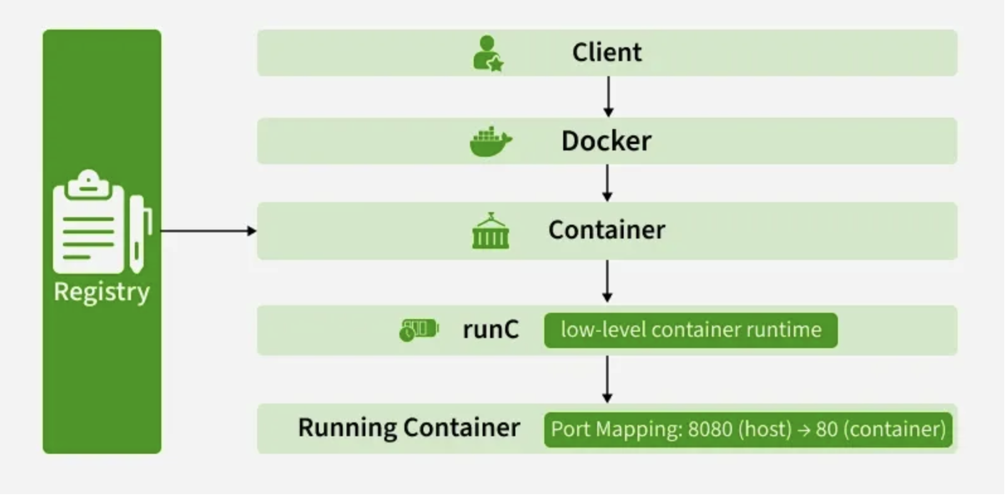
The Core Architectural Model
- Docker Client: This is your command center. When you type commands like docker run or docker build, you're using the Docker Client.
- Docker Host: This is the machine where the magic happens. It runs the Docker Daemon (dockerd) and provides the environment to execute and run containers.
- Docker Registry: This is a remote repository for storing and distributing your Docker images.
This interaction forms a simple yet powerful loop: you use the Client to issue commands to the Daemon on the Host, which can pull images from a Registry to run as containers.
Detailed Breakdown of Core Components -

1. The Docker Daemon (dockerd):
The Docker Daemon is the persistent background process that acts as the brain of your Docker installation.
- It runs on the Docker Host.
- It listens for API requests from the Docker Client.
- It manages all Docker objects: images, containers, networks, and volumes.
- It can communicate with other daemons to manage Docker services in a multi-host environment (like a Docker Swarm cluster).

2. The Docker Client:
The Docker Client is the primary interface through which users interact with Docker. This is most commonly the Command Line Interface (CLI).
- It translates user commands like docker ps into REST API requests.
- These requests are sent to the Docker Daemon for processing.
- A single client can communicate with multiple daemons.
Common Commands:
- docker build: Builds an image from a Dockerfile.
- docker pull: Pulls an image from a registry.
- docker run: Creates and starts a container from an image.

3. The Docker Host
The Docker Host is the physical or virtual machine that provides the complete environment for executing and running containers. It comprises:
- The Operating System (and its kernel).
- The Docker Daemon.
- Images that have been pulled or built.
- Running Containers.
- Networks and Storage components.

4. The Docker Registry
A Docker Registry is a stateless, scalable storage system for Docker images.
- Public Registry: The default public registry is Docker Hub, which contains a vast collection of community and official images.
- Private Registries: Organizations often use private registries (like Harbor, AWS ECR, or Google Artifact Registry) to store proprietary images for security and control.

13. Can you tell something about docker namespace?
Ans. A namespace is basically a Linux feature that ensures OS resources partition in a mutually exclusive manner. This forms the core concept behind containerization as namespaces introduce a layer of isolation amongst the containers. In docker, the namespaces ensure that the containers are portable and they don't affect the underlying host. Examples for namespace types that are currently being supported by Docker – PID, Mount, User, Network, IPC.

14. Where are docker volumes stored in docker?
Ans. Volumes are created and managed by Docker and cannot be accessed by non-docker entities. They are stored in Docker host filesystem at /var/lib/docker/volumes/
15. List the most commonly used instructions in Dockerfile?
Ans. FROM: This is used to set the base image for upcoming instructions. A docker file is considered to be valid if it starts with the FROM instruction.
- LABEL: This is used for the image organization based on projects, modules, or licensing. It also helps in automation as we specify a key-value pair while defining a label that can be later accessed and handled programmatically.
- RUN: This command is used to execute instructions following it on the top of the current image in a new layer. Note that with each RUN command execution, we add layers on top of the image and then use that in subsequent steps.
- CMD: This command is used to provide default values of an executing container. In cases of multiple CMD commands the last instruction would be considered.

16. You’re tired of running multiple containers manually. How does Docker Compose help?
Ans. Docker Compose uses a YAML file (docker-compose.yml) to define and run multi-container applications.
Example for a 3-tier app:
version: "3"
services:
db:
image: mysql
volumes:
- db_data:/var/lib/mysql
backend:
build: ./backend
depends_on:
- db
frontend:
build: ./frontend
ports:
- "80:80"
volumes:
db_data:
Run everything with: docker-compose up -d

17. Your container isn’t responding. How would you troubleshoot it?
Ans. docker ps → Check if running
docker logs <id> → Check application logs
docker inspect <id> → View config/network info
docker exec -it <id> bash → Access inside the container
docker stats → Monitor CPU/memory usage
18. How will you ensure that a container 1 runs before container 2 while using docker compose?
Ans. Docker-compose does not wait for any container to be “ready” before going ahead with the next containers. In order to achieve the order of execution, we can use:
- The “depends_on” which got added in version 2 of docker-compose can be used as shown in a sample docker-compose.yml file below:

version: “2.4”
services:
backend:
build: .
depends_on:
-db
db:
image: postgress
The introduction of service dependencies has various causes and effects:
- The docker-compose up command starts and runs the services in the dependency order specified. For the above example, the DB container is started before the backend.
- docker-compose up SERVICE_NAME by default includes the dependencies associated with the service. In the given example, running docker-compose up backend creates and starts DB (dependency of backend).
- Finally, the command docker-compose stop also stops the services in the order of the dependency specified. For the given example, the backend service is stopped before the DB service.

19. Can a container restart by itself?
Ans. Yes, it is possible only while using certain docker-defined policies while using the docker run command. Following are the available policies:
1. Off: In this, the container won’t be restarted in case it's stopped or it fails.
2. On-failure: Here, the container restarts by itself only when it experiences failures not associated with the user.
3. Unless-stopped: Using this policy, ensures that a container can restart only when the command is executed to stop it by the user.
4. Always: Irrespective of the failure or stopping, the container always gets restarted in this type of policy.

20. What is the way to establish communication between docker host and Linux host?
Ans. This can be done using networking by identifying the “ipconfig” on the docker host. This command ensures that an ethernet adapter is created as long as the docker is present in the host.

21. Architecture of Kubernets?
Ans. 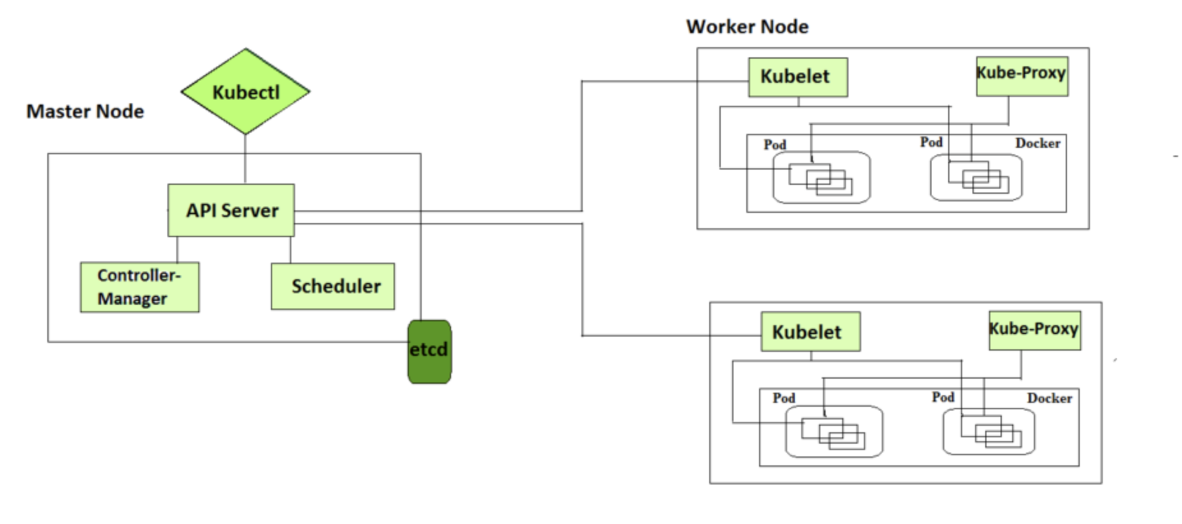
Control Plane Components
It is basically a collection of various components that help us in managing the overall health of a cluster. For example, if you want to set up new pods, destroy pods, scale pods, etc. Basically, 4 services run on Control Plane:

1. Kube-API server
The API server is a component of the Kubernetes control plane that exposes the Kubernetes API. It is like an initial gateway to the cluster that listens to updates or queries via CLI like Kubectl. Kubectl communicates with API Server to inform what needs to be done like creating pods or deleting pods etc. It also works as a gatekeeper. It generally validates requests received and then forwards them to other processes. No request can be directly passed to the cluster, it has to be passed through the API Server.

2. Kube-Scheduler
When API Server receives a request for Scheduling Pods then the request is passed on to the Scheduler. It intelligently decides on which node to schedule the pod for better efficiency of the cluster.

3. Kube-Controller-Manager
The kube-controller-manager is responsible for running the controllers that handle the various aspects of the cluster's control loop. These controllers include the replication controller, which ensures that the desired number of replicas of a given application is running, and the node controller, which ensures that nodes are correctly marked as "ready" or "not ready" based on their current state.

4. etcd
It is a key-value store of a Cluster. The Cluster State Changes get stored in the etcd. It acts as the Cluster brain because it tells the Scheduler and other processes about which resources are available and about cluster state changes.

Node Components
These are the nodes where the actual work happens. Each Node can have multiple pods and pods have containers running inside them. There are 3 processes in every Node that are used to Schedule and manage those pods.
The following are the some of the components related to Node:

1. Container runtime
A container runtime is needed to run the application containers running on pods inside a pod. Example-> Docker

2. kubelet
kubelet interacts with both the container runtime as well as the Node. It is the process responsible for starting a pod with a container inside.

3. kube-proxy
It is the process responsible for forwarding the request from Services to the pods. It has intelligent logic to forward the request to the right pod in the worker node.

22. How to get the central logs from POD?
Ans. This architecture depends upon the application and many other factors. Following are the common logging patterns
- Node level logging agent.
- Streaming sidecar container.
- Sidecar container with the logging agent.
- Export logs directly from the application.
In the setup, journalbeat and filebeat are running as daemonset. Logs collected by these are dumped to the kafka topic which is eventually dumped to the ELK stack.
The same can be achieved using EFK stack and fluentd-bit.
23. What is the role of Load Balance in Kubernetes?
Ans. Load balancing is a way to distribute the incoming traffic into multiple backend servers, which is useful to ensure the application available to the users.
In Kubernetes, as shown in the above figure all the incoming traffic lands to a single IP address on the load balancer which is a way to expose your service to outside the internet which routes the incoming traffic to a particular pod (via service) using an algorithm known as round-robin. Even if any pod goes down load balances are notified so that the traffic is not routed to that particular unavailable node. Thus load balancers in Kubernetes are responsible for distributing a set of tasks (incoming traffic) to the pods
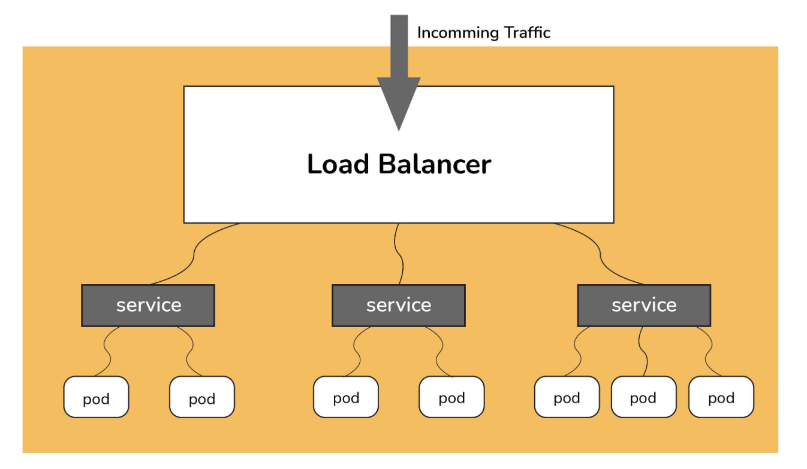

24. What are the different ways to provide external network connectivity to K8?
Ans. By default, POD should be able to reach the external network but vice-versa we need to make some changes. Following options are available to connect with POD from the outer world.
- Nodeport (it will expose one port on each node to communicate with it)
- Load balancers (L4 layer of TCP/IP protocol)
- Ingress (L7 layer of TCP/IP Protocol)
Another method is to use Kube-proxy which can expose a service with only cluster IP on the local system port.
$ kubectl proxy --port=8080 $ http://localhost:8080/api/v1/proxy/namespaces//services/:/

25. Can you explain the differences between Docker Swarm and Kubernetes?
Ans. Below are the main difference between Kubernetes and Docker:
- The installation procedure of the K8s is very complicated but if it is once installed then the cluster is robust. On the other hand, the Docker swarm installation process is very simple but the cluster is not at all robust.
- Kubernetes can process the auto-scaling but the Docker swarm cannot process the auto-scaling of the pods based on incoming load.
- Kubernetes is a full-fledged Framework. Since it maintains the cluster states more consistently so autoscaling is not as fast as Docker Swarm.

26. What’s the init container and when it can be used?
Ans. init containers will set a stage for you before running the actual POD.
Wait for some time before starting the app Container with a command like sleep 60. Clone a git repository into a volume.
27. What is Ingress Default Backend?
Ans. It specifies what to do with an incoming request to the Kubernetes cluster that isn't mapped to any backend i.e what to do when no rules being defined for the incoming HTTP request If the default backend service is not defined, it's recommended to define it so that users still see some kind of message instead of an unclear error.

28. How to troubleshoot if the POD is not getting scheduled?
Ans. In K8’s scheduler is responsible to spawn pods into nodes. There are many factors that can lead to unstartable POD. The most common one is running out of resources, use the commands like kubectl describe <POD> -n <Namespace> to see the reason why POD is not started. Also, keep an eye on kubectl to get events to see all events coming from the cluster.

29. How can we forward the port '8080 (container) -> 8080 (service) -> 8080 (ingress) -> 80 (browser)and how it can be done?
Ans. The ingress is exposing port 80 externally for the browser to access, and connecting to a service that listens on 8080. The ingress will listen on port 80 by default. An "ingress controller" is a pod that receives external traffic and handles the ingress and is configured by an ingress resource For this you need to configure the ingress selector and if no 'ingress controller selector' is mentioned then no ingress controller will manage the ingress.
Simple ingress Config will look like
host: abc.org
http:
paths:
backend:
serviceName: abc-service
servicePort: 8080
Then the service will look like
kind: Service
apiVersion: v1
metadata:
name: abc-service
spec:
ports:
protocol: TCP
port: 8080 # port to which the service listens to
targetPort: 8080

30. How should TLS be configured with Ingress?
Ans. Add tls and secretName entries.
spec:
tls:
- hosts:
- some_app.com
secretName: someapp-secret-tls

31. Explain the workflow of the core terraform.
Ans. Terraform's core workflow consists of three steps:

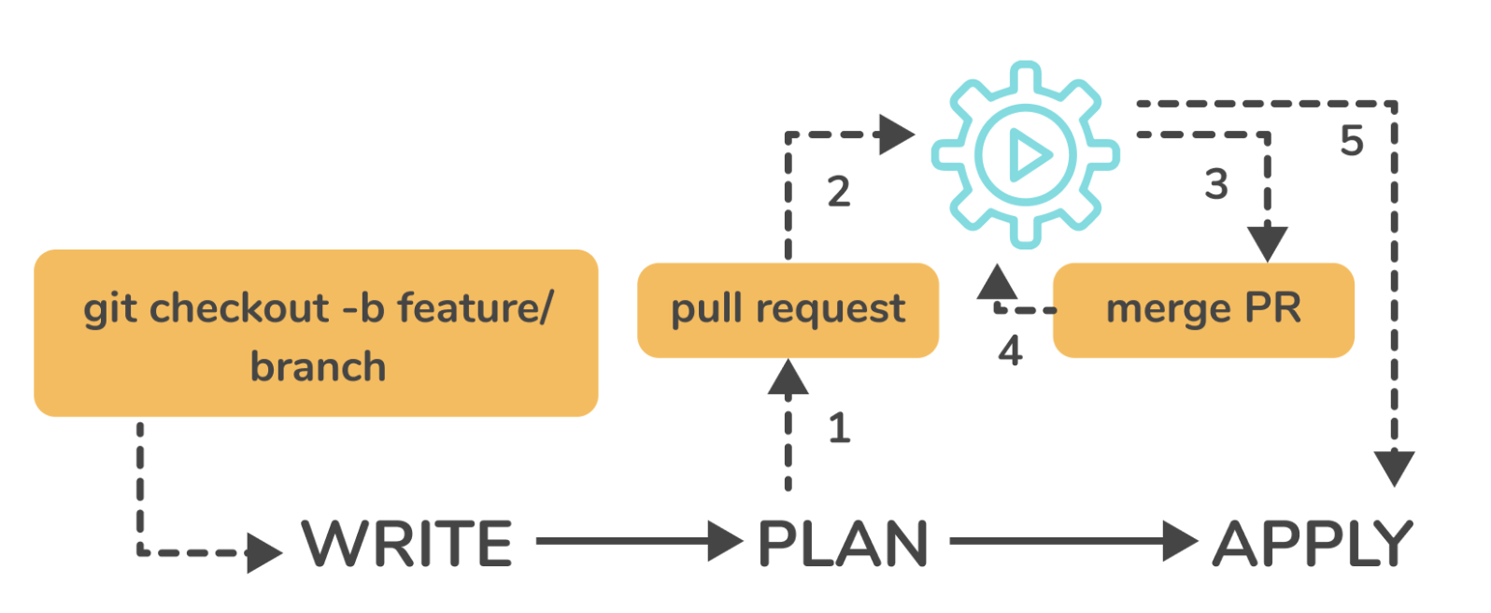
- Write - Create infrastructure in the form of code.
- Plan - Plan ahead of time to see how the changes will look before they are implemented.
- Apply - Create a repeatable infrastructure.

32. What are the key features of Terraform?
Ans. Following are the key features of Terraform:
- Infrastructure as Code: Terraform's high-level configuration language is used to describe your infrastructure in declarative configuration files that are human-readable. You may now generate a blueprint that you can edit, share, and reuse.
- Execution Strategies: Before making any infrastructure modifications, Terraform develops an execution plan that describes what it will do and asks for your agreement. Before Terraform produces, upgrades, or destroys infrastructure, you can evaluate the changes.
- Graph of Resources: Terraform develops or alters non-dependent resources while simultaneously building a resource graph. This allows Terraform to construct resources as quickly as possible while also providing you with more information about your infrastructure.
- Automation of Change: Terraform can automate the application of complex changesets to your infrastructure with little to no human intervention. Terraform identifies what happened when you update configuration files and provides incremental execution plans that take dependencies into account.

33. Explain State File Locking in the context of Terraform.
Ans. Terraform's state file locking method prevents conflicts between numerous users doing the same task by blocking activities on a given state file. When one user unlocks the lock, only the other user has access to that state. Terraform will lock your state for any operations that potentially write state if your backend supports it. This prevents outsiders from gaining access to the lock and corrupting your state. All operations that have the potential to write state are automatically locked. There will be no indication that this is happening. Terraform will not continue if state locking fails. The -lock flag can be used to deactivate state locking for most tasks, although it is not advised. Terraform will send a status message if gaining the lock takes longer than planned. If your backend enables state locking, even if Terraform doesn't send a message, it still happens.

34. How can you prevent Duplicate Resource Error in Terraform?
Ans. Depending on the situation and the necessity, it can be accomplished in one of three ways.
- By destroying the resource, the Terraform code will no longer manage it.
- By removing resources from APIs
- Importing action will also aid in resource elimination.

35. Explain the command terraform taint in the context of Terraform.
Ans. Terraform receives notification from the terraform taint command that a specific item has been degraded or damaged. This is represented by Terraform designating the item as "tainted" in the Terraform state, in which case Terraform will suggest replacing it in the next plan you write. If you want to compel the replacement of a specific object despite the fact that no configuration modifications are required, using the terraform apply -replace option is preferred.
Utilizing the "replace" option while creating a plan is preferable to using terraform taint because it allows you to see the entire impact of the alteration before taking any externally visible action. When you utilise terraform taint to achieve a similar impact, you run the danger of someone else on your team devising a new strategy to counter your tainted object before you've had a chance to consider the implications.
Syntax:
terraform taint [options] address
The address option specifies the location of the infected resource. The following options are available with this command:
- -allow-missing - Even if the resource is absent, the command will succeed (exit code 0) if it is supplied. Other scenarios, such as a problem reading or writing the state, may cause the command to return an error.
- -lock=false - Turns off Terraform's default behaviour of attempting to lock the state for the duration of the operation.
- -lock-timeout=DURATION - Instructs Terraform to reattempt procuring a lock for a period of time before issuing an error, unless locking is disabled with -lock=false. A number followed by a time unit letter, such as "3s" for three seconds, is the duration syntax.

36. What procedures should be taken to make a high-level object from one module available to the other module?
Ans. The steps to make an object from one module available to the other module at a high level are as follows:
- The first step is to define an output variable in a resource configuration. The scope of local and to a module will not be declared until you define resource configuration details.
- Now you must specify the output variable of module A so that it can be utilised in the setup of other modules. You should establish a fresh new and up-to-date key name, with a value that is equal to the output variable of module A.
- You must now create a file named variable.tf for module B. Create an input variable with the exact same name as the key you defined in module B inside this file. This variable permits the resource's dynamic setting in a module. Replicate the process to make this variable available to other modules as well. This is because the scope of the variable established here is limited to module B.

37. Your company is manually creating AWS resources using the console, which is slow and error-prone. How would you automate infrastructure deployment?
Ans. I’d use Infrastructure as Code (IaC) — which allows infrastructure provisioning using code.
Tools like Terraform, CloudFormation, and Pulumi help define, deploy, and manage resources consistently and repeatably.

38. Your team wants a tool to manage infrastructure across AWS, Azure, and GCP using a single syntax. Why choose terraform.
Ans. Terraform is a cloud-agnostic IaC tool developed by HashiCorp that provisions and manages infrastructure using configuration files written in HCL (HashiCorp Configuration Language).
It integrates with multiple cloud providers via providers (AWS, Azure, GCP).

39. Deploy a single EC2 instance using Terraform.
Ans. provider "aws" {
region = "ap-south-1"
}
resource "aws_instance" "my_ec2" {
ami = "ami-0abcd12345"
instance_type = "t2.micro"
tags = {
Name = "TerraformDemo"
}
}
Commands:
terraform init
terraform plan
terraform apply
terraform destroy

40. You need to create an auto-scaling web tier with a load balancer.
Ans. Create Launch Template for EC2.
Define Auto Scaling Group to manage scaling.
Add an Application Load Balancer (ALB) for distributing traffic.
Use Terraform dependencies to ensure LB is created before ASG.

41. Tell me something about Continuous Integration, Continuous Delivery, and Continuous Deployment?
Ans. Continuous Integration: A software development process where the changes made to software are integrated into the main code as and when a patch is ready so that the software will be always ready to be - built, tested, deployed, monitored - continuously.
Continuous Delivery: This is a Software Development Process where the continuously integrated (CI) changes will be tested & deployed continuously into a specific environment, generally through a manual release process, after all the quality checks are successful
Continuous Deployment: A Software Development practice where the continuously integrated (CI) changes are deployed automatically into the target environment after all the quality checks are successful
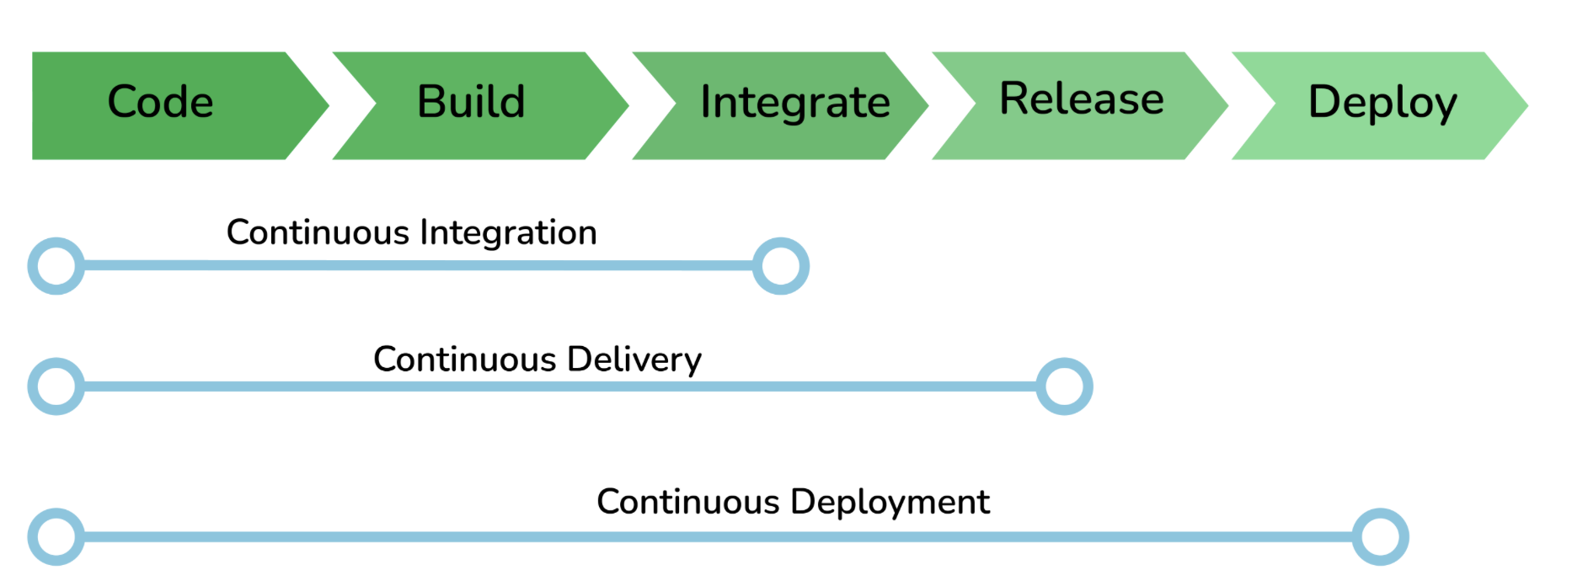
42. What is a Jenkins job?
Ans. A Job/Project is the fundamental unit of a logical work (like a software build, an automation task, test execution, etc) using the Jenkins automation server and other required plugins, configurations & infrastructures.
Jobs can be of different types like - a freestyle project, a multi-configuration project, a pipeline project, a multi-branch project, etc.
43. What are the ways to trigger a Jenkins Job/Pipeline?
Ans. There are many ways we can trigger a job in Jenkins. Some of the common ways are as below -
- Trigger an API (POST) request to the target job URL with the required data.
- Trigger it manually from the Jenkins web application.
- Trigger it using Jenkins CLI from the master/slave nodes.
- Time-based Scheduled Triggers like a cron job.
- Event-based Triggers like SCM Actions (Git Commit, Pull Requests), WebHooks, etc.
- Upstream/Downstream triggers by other Jenkins jobs.

44. What happens when a Jenkins agent is offline and what is the best practice in that situation?
Ans. When a job is tied to a specific agent on a specific node, the job can only be run on that agent and no other agents can fulfill the job request. If the target node is offline or all the agents on that particular node are busy building other jobs, then the triggered job has to wait until the node comes online or an agent from that node becomes available to execute the triggered build request.
As a result, a triggered job may sometimes wait indefinitely without knowing that the target node is offline. So, it is always the best practice to tie the jobs to a group of nodes & agents, referred to with a 'Label'. Once a job is tied to a Label, instead of a specific node/agent, any of the nodes/agents falling under the label can fulfill a build request, when a job is triggered. This way we can reduce the overall turn-around time of the builds.
Even then if a job is waiting for more time for the nodes/agents, then it is time to consider adding more nodes/agents.
45. What is Jenkins Build Cause?
Ans. Build Cause is a text attribute that represents what made a job's build to be triggered, say it could be a Jenkins User (from UI), Timer for Scheduled jobs, Upstream jobs for a job which was triggered by upstream job, etc. This is mainly used to identify the nature of the builds - be it nightly, manual, automated, etc.
46. What are some Key benefits of using Datadog?
Ans.
- Datadog is used for correlating metrics from our Apps, Tools, SaaS, Cloud providers and services which consists Web Servers, StatsID, SQL, NoSQL Databases.
- Datadog can easily analyze, alert, graph our mass of data by using real-time dashboards.
- Datadog can filter performance metrics so we can focus on those matters.
- Datadog supports team collaboration by changing and commenting annotations for our production data.
47. Datadog Agent is written in which Language?
Ans. Go
Python
Java
C++

48. Your company has several EC2 instances, Docker containers, and Kubernetes pods, but there’s no unified visibility into performance or logs. How can Datadog help in this case?
Ans. Datadog is a cloud-based monitoring and observability platform that provides real-time visibility into infrastructure, applications, and logs — all in one place.
It integrates with 500+ technologies (like AWS, Docker, Kubernetes, etc.) and offers dashboards, alerts, and analytics for proactive monitoring.

49. You want to monitor a Linux EC2 instance’s CPU, memory, and disk metrics.
How do you install the Datadog Agent?
Ans. DD_API_KEY=<your_api_key> \
DD_SITE="datadoghq.com" \
bash -c "$(curl -L https://s3.amazonaws.com/dd-agent/scripts/install_script.sh)"
The agent collects system metrics and sends them to the Datadog platform for visualization and alerting.

50. You’ve installed the agent and need to visualize metrics. What main components will you find in the Datadog web UI?
Ans. Infrastructure List / Host Map → shows all hosts and containers
Dashboards → visualize metrics and logs
Monitors → configure alerts
Integrations → connect to AWS, Docker, etc.
Logs & APM → view application traces and logs

